Lesson 1: Dudley and Stephens Case

Read the court case below. Once you have finished, write a response to each of the questions in a Word file and email it to me.

R. vs. Dudley and Stephens (1884) England 14 L.R. 273

The accused Dudley and Stephens, along with Brooks and a seventeen-year-old, Parker, were cast away in a storm on the high seas 1600 miles (about 2500 km) from the Cape of Good Hope and were compelled to put into an open boat. They had no water and only two, one-pound (454g) tins of turnip for food. On the fourth day they caught a small turtle, and then had no other food until the twentieth day. They managed to catch some rainwater in their oilskin capes.

On the eighteenth day, Dudley and Stephens spoke to Brooks as to what should be done if no more food was obtained and suggested that one of them should be sacrificed to save the rest. Brooks dissented, and the boy to whom they were understood to refer was not consulted. The accused had said that the boy was suffering the most, and he alone had no family to return to.

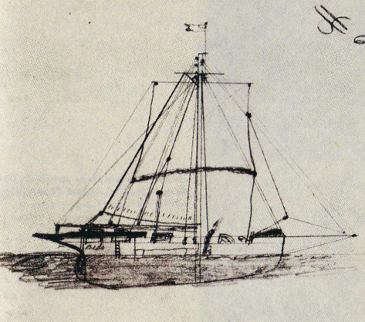
On the twentieth day, Dudley told Parker that he had better go and have a sleep and made signs to Stephens and Brooks that the boy had better be killed. Stephens agreed. Brooks dissented. Dudley offered a prayer, and with the assent of Stephens went to the boy and put a knife into his throat, killing him. The men then fed on the body and blood of the boy for four days, at which time they were picked up by a passing vessel. They were returned to England, where Dudley and Stephens were put on trial for murder.

Assignment:

Read the above case over a few times. When you understand everything that took place, you can do the questions that follow on a separate piece of paper. Just send it to me when you are done and contact me with ANY questions you have, or if you just want to discuss it. I would love to hear from you. Good luck!

R. vs. Dudley and Stephens (1884) England

1. Should Stephens and Dudley have been accused of a wrong? Should Brooks?

2. Different laws are made by different societies. Did this four-man group on a stranded boat consist of a society? If so, do you think that the laws governing our society should apply to this four-man society?

3. Would your answer be different if the three older boys had agreed and had still not consulted Parker? What if they had drawn lots (straws)?

4. The stronger boys had a vote in the decision to kill the weaker. Does our society allow the stronger to dominate the weaker? Explain.

5. Was the decision made by Dudley and Stephens right or wrong? What makes a decision right or wrong?

6. Are there any circumstances when an exception to a given rule of law might prevail?

7. Five judges tried the case. The argument presented by the defense dealt mainly with the necessity of the accused’s action. It is ever necessary to take another’s life? Does anyone ever have a duty to die for others?

8. A similar incident has occurred in Canada. A plane crashed in the Arctic and one of the survivors resorted to eating the flesh of a victim of the crash. In what way does this situation differ from the Dudley and Stephens case? Should Dudley and Stephens have waited for one person to die before eating his body?

9. How would you punish Dudley and Stephens? Explain.

